What Are Your Top Incentives?
- Review the following list of work incentives.
- Put a check mark beside the incentive that you would like to receive.
- Check as many as you like, as long as they are ones that really appeal to you!
1. Be introduced to external contacts as an expert by your manager.
2. Rescue a task that is causing problems for other employees.
3. Work on a team with people you like.
4. Be able to apply for an assignment that you haven’t done before.
5. Receive unexpected time off after completing a particularly difficult task.
6. See the results of your efforts.
7. Provide input to external consultants on how your work unit operates.
8. Learn a new set of skills for immediate application at work.
9. Receive an e-mail from your manager that has positive comments about you and has been copied throughout the organization.
10. Be in a position in which your decisions affect others.
11. Orient new employees to the organization.
12. Receive an assignment that makes your job more interesting.
13. Be given verbal recognition for your work from a senior manager at a company event.
14. Be asked to organize a company social event.
15. Know that others are depending on what you do.
16. Take on a task that most employees would find difficult.
17. Be asked to take on a mentor role for your work unit.
18. Have a job that you are proud to describe to your friends.
19. Have an article about you and what you have accomplished appear in the company newsletter or on the intranet site.
20. Represent the department at an inter-departmental meeting.
21. Work on tasks that have a direct impact on the customer.
22. Be given a special assignment to solve a key problem.
23. Receive a plaque at an official event recognizing your achievements.
24. Have the opportunity to try a new method in an existing process.

Meaning | Achievement | Recognition | Belonging
6 | 2 | 1 | 3
10 | 4 | 5 | 7
12 | 8 | 9 | 11
15 | 16 | 13 | 14
18 | 22 | 19 | 17
21 | 24 | 23 | 20
TOTAL | TOTAL | TOTAL | TOTAL

Score Sheet:

What Are Your Top Incentives?
- Transfer your responses to the columns below.
- Put a check mark next to the numbers that correspond to the items you selected on the survey.
- Add the number of check marks for each column.

Engagement Diamond
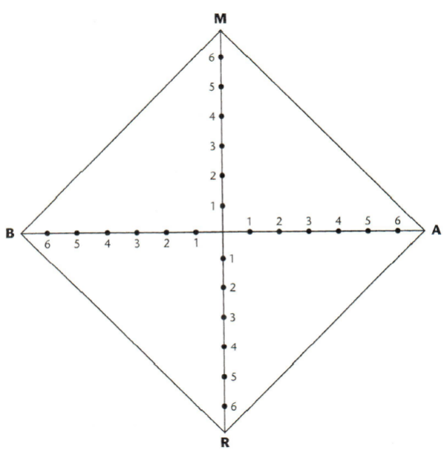
- Transfer your scores to the diamond to the right by circling the appropriate number for each of the letters (Meaning, Achievement, Recognition, Belonging).
- Connect the dots to create your “Engagement Diamond.”

